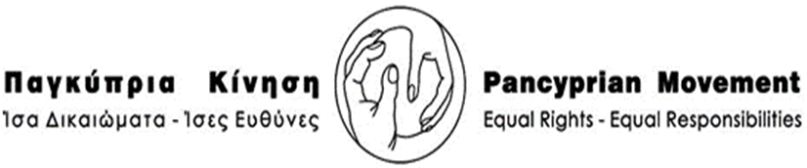
09:00 - 09:30 | Registration
09:30 - 10:15 | Welcome speeches  1. Mrs Kyriaki Koumides, President of Pancyprian Movement of Equal Rights -Equal Responsibilities  2. Mrs Ioanna Maganara, President of International Alliance of Women  3. Dr. Kalliope Agapiou Josephides, Chairperson of the EIGE Management Board  4. The Minister of Justice and Public Order Mr Ionas Nicolaou  Choir ‘’Finding our voices’’ by Caritas Org. Conductor Mrs Demetra Constantinou
10:15 - 10:45 | Coffee Break
10:45 - 11:30 | Presentation of Dr Kalliope Agapiou Josephides ‘’Women, Peace and Security: From Unacknowledged Policies and Ignored Consequences to promising prospects?’’
11:30 - 12:00 | Presentation of Mrs Niovi Georgiade, Officer/ Representative of The Commissioner for Administrations and Human Rights (Ombudsman) ‘’Combating discrimination on the ground of Gender: The experience of the Office of the Commissioner for Administration and Human Rights”
12:00 - 12:30 | Interventions, Questions and Discussions with participants
13:00 - 14:30 | Lunch Break
14:30 - 15:15 | Presentation of Mrs Signe Vahlum – IAW Denmark “Digital Sexual Assault - Α new form of violence against women”
15:15 - 15:30 | Coffee Break
15:30 - 16: 15 | Presentation of Mrs Ursula Nakamura & Gudrun Haupter IAW Health Committee ‘’ Water and sanitary towels for girls in developing countries’’
16:15 - 16: 45 | Questions and Discussion
SEMINAR AGENDA
Tuesday 24 October 2017
“Eliminating Violence against Women & girls - Winning Peace and prosperity in the World”

